Task 2

2.3)

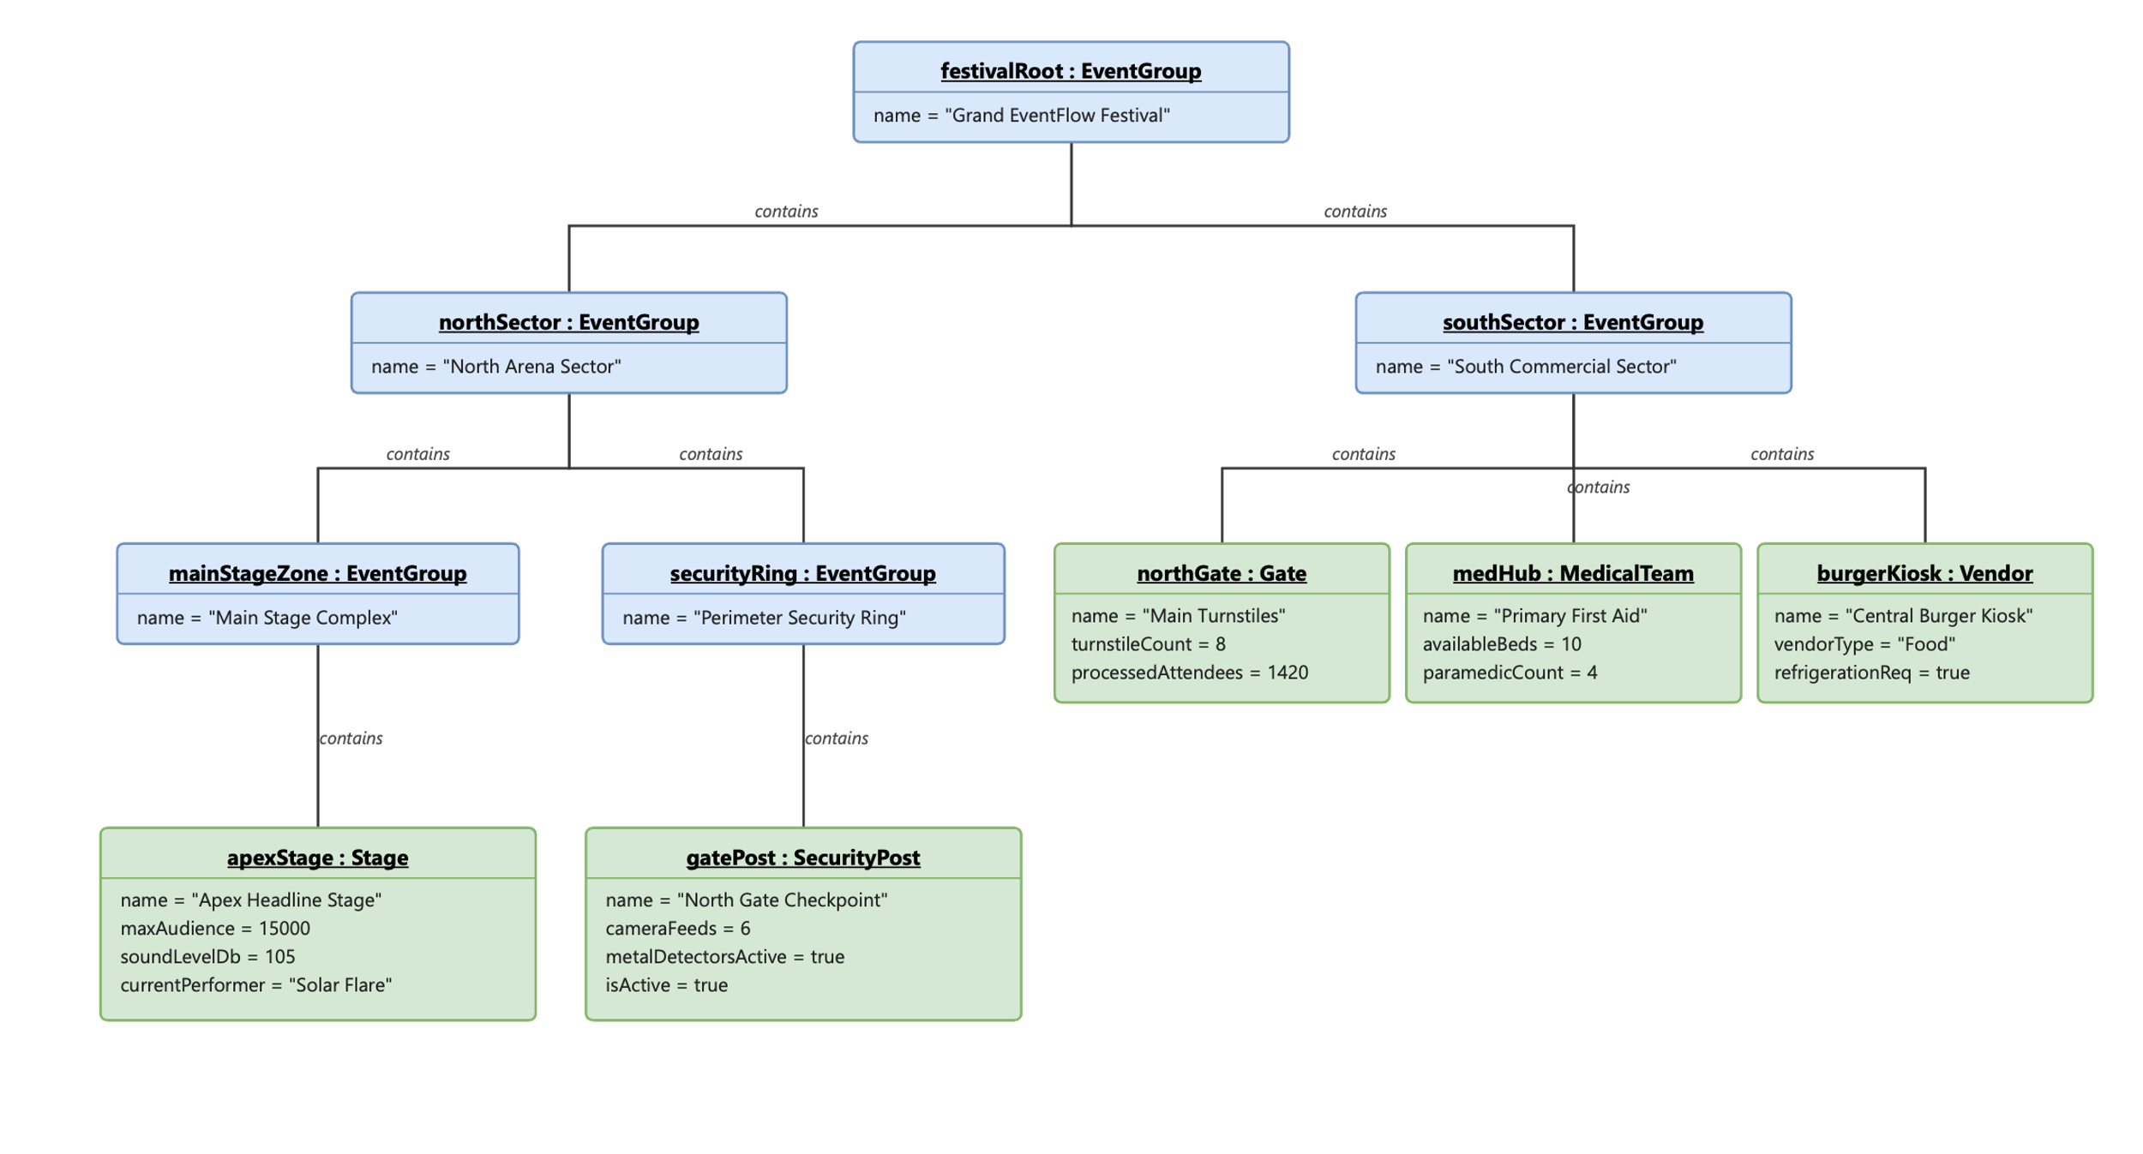

2.4)
Why the subtree is released exactly once: EventComponent has a virtual destructor, so delete on a base pointer always resolves to the correct derived destructor. EventGroup's destructor iterates its children container and deletes each one; if a child is itself a Composite, this recurses automatically. This works safely because every component is owned by exactly one parent at a time (never referenced from two containers), making the tree a true tree with no cycles or shared nodes — so one recursive walk from the root visits, and destroys, every node exactly once.
Transfer ownership rules: Transferring a component calls remove() on the old parent (erases the pointer, does not delete) before add() on the new parent, so the component is never owned by two composites at once and never left dangling. Only the owning composite may delete a component — no other class holds that authority. If the component is also a registered Observer, detach()/attach() are called alongside the transfer so ownership and observation stay consistent. This prevents double deletion structurally: at any instant, exactly one owner exists.

